Elemental Health LLC
Massage Therapy and Bodywork Medical History Form

Name ______________________________________________

Address ____________________________________________

City ______________________________ Zip Code _________________________

Phone ______________________________ Email __________________________________________

What brings you to massage therapy at this time?

What do you hope to accomplish through massage therapy?

Have you had a professional massage before?

How frequently?

What did you like about your prior experiences?

What did you dislike about your prior experiences?

Please circle any of the following that apply :

Musculoskeletal:

Bone or joint disease
Tendonitis/bursitis
Jaw pain/tmj
Spinal problems
Migraines
headaches

Circulatory Concerns

Heart conditions
Varicose Veins
History of blood clots
Blood pressure low/high

Respiratory Conditions

Breathing difficulty
Sinus Problems
Sleep apnea

Nervous System

Shingles
Numbness/Tingling
Pinched Nerves
Chronic pain
MS
Parkinson’s Disease

Skin

Allergies
Rashes
Athlete’s foot
Cosmetic surgery

Digestion

Irritable Bowel Syndrome
Crohn’s disease
Bladder/Kidney ailments
Ulcers

Psychological

Anxiety
Stress
Depression
Mental ‘fogginess’/fatigue
insomnia

Other

Lifestyle
How often do you exercise:
Daily 4-5 x per week 2-3 times per week

Weekly 2 x per month once per month

Please describe your exercise activities

How much water do you drink per day?

Please indicate on the drawings where you have had surgeries, chronic pain, or areas of concern for massage therapy

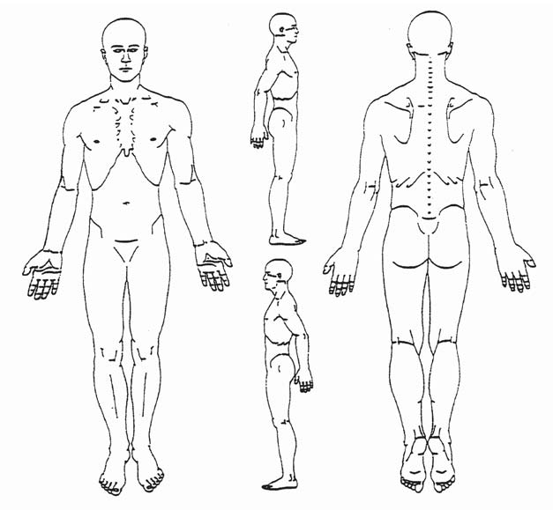

Client Agreement for Treatment:
It is my choice to receive massage therapy. I am aware of the benefits and risks of massage and give my consent for massage. I understand that there is no implied or stated guarantee of success of effectiveness of individual techniques or series of appointments. I acknowledge that massage therapy is not a substitute for medical care, medical examination or diagnosis. I have stated all medical conditions that I am aware of and will inform my practitioner of any changes in my health status.
I commit to open discussion with Elemental Health practitioners regarding any concerns I have during or following treatment.
I agree to pay the disclosed amount of treatment at the time services are rendered. I agree to pay for missed scheduled appointments if I should have to cancel with less than 24 hours of notice.

Signed:___________________________________________________ Date _________________

